***Research Report: Internet of Things (IoT) and MQTT Protocol Analysis***

**Abstract**

The **Internet of Things (IoT)** is changing how technology works by connecting everyday devices to the internet. This allows them to automatically collect and share information with each other. This report explains what IoT is, shows how to create a simple **smart home** using a tool called **Cisco Packet Tracer**, and looks at the **MQTT protocol**, which is often used to help IoT devices talk to each other. The report also explains why IoT is important in today’s technology and how **MQTT** makes communication between devices easier and more efficient.

**Introduction**

The Internet of Things (IoT) is a system where devices like sensors, software, and other technologies are connected to each other to collect and share data. IoT has become very popular because it can automate tasks, make things work more efficiently, and improve our daily lives in areas like smart homes, healthcare, and industrial automation.

**Why is IoT important?**  
IoT differs from traditional computer networking in that it involves heterogeneous devices and large-scale automation. The motivation behind IoT is to create smarter environments that reduce human intervention, optimize resources, and improve connectivity between devices.

**Technological Discussion**

**What is IoT?**

IoT, or the **Internet of Things**, refers to connecting everyday physical devices to the internet so they can **collect, send, and receive data**. These devices can be anything from **home appliances** like refrigerators and washing machines, to **industrial machines** used in factories, to **wearable devices** like fitness trackers, and even **sensors** used in smart cities to monitor things like traffic or air quality. Once connected to the internet, these devices can work together, share information, and perform tasks automatically, often without the need for human input. This helps make daily life and business processes more efficient and convenient.

**Key Technologies and Concepts**

* **Sensors and Actuators:** These are essential parts of IoT systems. Sensors collect information from the environment (like temperature, humidity, or motion), while actuators perform actions (like turning on lights or adjusting a thermostat) based on that data.
* **Connectivity:** IoT devices use wireless technologies like Wi-Fi, Bluetooth, Zigbee, and LoRaWAN to connect with each other and the internet. This allows them to send and receive data from servers or other devices.
* **MQTT Protocol:** MQTT is a simple and effective way for IoT devices to communicate. It uses a system called "publish/subscribe," where devices send information to a topic (publish), and other devices receive the information by subscribing to that topic. This method is efficient, even when devices have limited power or internet speed.

**Applications of IoT**

* **Smart Homes:** In smart homes, IoT devices manage things like lighting, temperature, and security systems. These devices can automatically adjust settings based on preferences or activity, making life more convenient and energy-efficient.
* **Healthcare:** Wearable IoT devices, like fitness trackers or medical monitors, collect health data from patients. This information is shared with healthcare professionals in real time, helping them monitor and manage patient health more effectively.
* **Industrial IoT (IIoT):** In industries, IoT technology automates processes and helps predict when machines need maintenance. This improves efficiency, reduces downtime, and allows for smoother operations in factories and other industrial settings.

**IoT Use Case: Smart Home Implementation in Cisco Packet Tracer**

**Overview of Smart Home**

In a **smart home** IoT system, devices like **smart thermostats**, **smart lights**, and **security cameras** are all connected to a central network. These devices can communicate with each other, share data, and respond to commands. For example, a smart thermostat can change the temperature based on movement in the house or a set schedule, while smart lights can automatically turn on or off when someone walks in or out of a room.

What makes this system even better is that you can control all of these devices from anywhere using a **mobile app** or a **voice assistant** like Google Home or Amazon Alexa. This means you can check what's happening at home, turn appliances on or off, or even watch your security cameras from anywhere in the world as long as you're connected to the internet. The system makes life more convenient, saves energy, and keeps your home more secure by automating everyday tasks and allowing you to monitor things in real time.

**Cisco Packet Tracer Implementation**

Using **Cisco Packet Tracer**, we implemented a simple **smart home network**. The IoT devices included:

* **Smart lights**: These are controlled by sensors that turn them on or off depending on the presence of occupants.
* **Smart thermostat**: This adjusts the temperature based on environmental data collected by sensors.
* **Security camera**: This records video and sends alerts to mobile devices when motion is detected.

The communication between devices was facilitated by an **MQTT broker**, which ensured seamless data exchange between devices and control applications.

**Diagram: Smart Home Setup**

**smart home implementation** in Cisco Packet Tracer, showing the connected IoT devices (e.g., smart lights, thermostats, security cameras) and their communication with the MQTT broker.

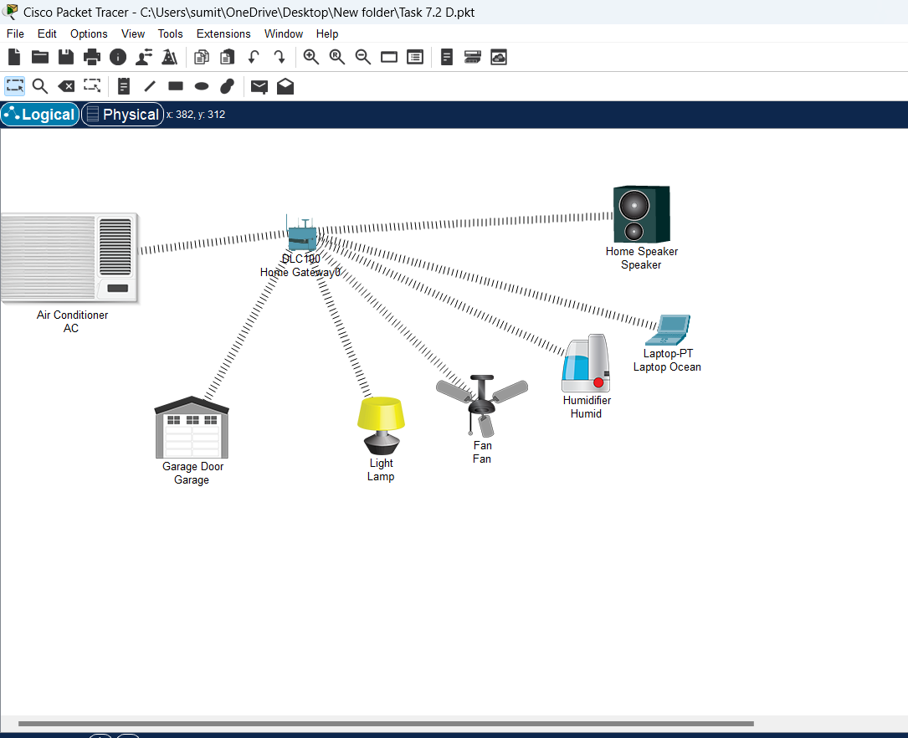

**MQTT Protocol Analysis**

**What is MQTT?**

**MQTT (Message Queuing Telemetry Transport)** is a simple and efficient messaging system designed for places with limited internet speed or where devices have low power. It works using a publish/subscribe model, meaning devices can send (or "publish") information to specific topics, and other devices can choose to receive (or "subscribe" to) updates from those topics. This makes it perfect for IoT systems where devices need to share information efficiently.

**MQTT in Cisco Packet Tracer**

In the **smart home** use case, we implemented an **MQTT broker** on a local laptop, allowing smart devices (such as lights and cameras) to communicate via the MQTT protocol. The **publish/subscribe** model ensured efficient data transmission, minimizing network load.

**Analysis of MQTT in Action**

* **Efficiency**: MQTT was efficient in terms of bandwidth usage, with small message sizes and minimal network overhead.
* **Latency**: The protocol demonstrated low latency, enabling real-time control of IoT devices.
* **Reliability**: MQTT’s **Quality of Service (QoS)** levels ensured reliable message delivery between devices.

**Demonstration Video**

A 1-2 minute video of the **MQTT protocol** in action within the Cisco Packet Tracer smart home simulation is provided. This demonstrates how devices publish and subscribe to topics, with real-time updates and control.

<https://youtu.be/VTlnb34bjgM>

**Conclusion**

The Internet of Things is fundamentally transforming the way devices interact with each other and with the internet. The **MQTT protocol**, as demonstrated in the smart home implementation, plays a vital role in enabling efficient communication between IoT devices. This research highlights the significance of IoT in creating smarter, more automated environments and the importance of lightweight communication protocols like MQTT in managing large-scale networks of interconnected devices.

**References**

Ensure to include references following the **IEEE style** as required. Here are some sample entries:

1. K. Ashton, "That 'Internet of Things' Thing," RFID Journal, July 2009. [Online]. Available: https://www.rfidjournal.com/articles/view?4986. [Accessed: Sept. 28, 2024].
2. IBM Developer Works, "MQTT and the Internet of Things," [Online]. Available: https://developer.ibm.com/articles/iot-mqtt-why-good-for-iot/. [Accessed: Sept. 28, 2024].
3. G. Morabito, V. Cozzolino, "The Role of the MQTT Protocol in the Internet of Things (IoT)," 2017. [Online]. Available: https://www.researchgate.net/publication/321645494_The_Role_of_the_MQTT_Protocol_in_the_Internet_of_Things_IoT. [Accessed: Sept. 28, 2024].
4. M. Ammar, G. Russello, B. Crispo, "Internet of Things: A Survey on the Security of IoT Frameworks," Journal of Information Security, 2018. [Online]. Available: https://ieeexplore.ieee.org/document/8435940. [Accessed: Sept. 28, 2024].
5. E. Al-Tamimi, "The Importance of Security in the IoT and how MQTT Handles Security Issues," 2020. [Online]. Available: https://arxiv.org/abs/2005.04589. [Accessed: Sept. 28, 2024].